**Python Scripting**

**1)Created the required Directories for timestamp**

**2)Added the files to it**

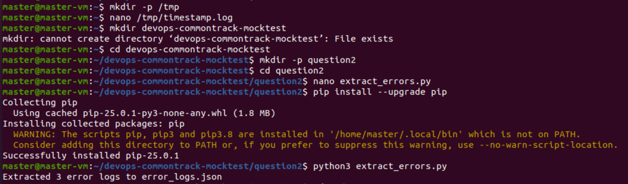

**3) Now next do Parse a “/tmp/timestamp.log” file**

**app.py file**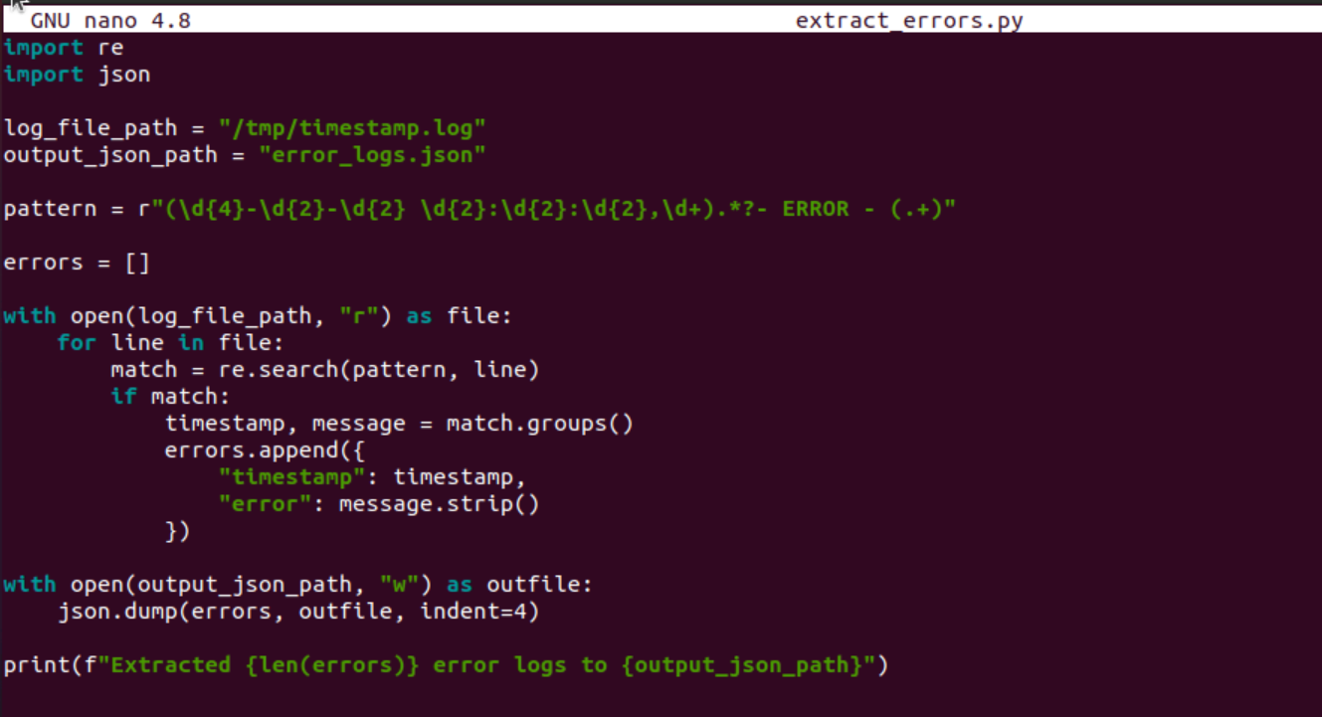

**4)Extracting all timestamps and error messages**

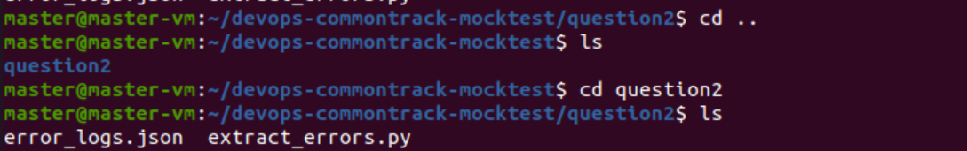

**5)Stored the output in a Json format in a file c**

